SBORS Group
Leader: Quines, John Melquisedec P.
Member: Ancheta, Arabelah May N.
De Vera, Glaiza G.
Fang, John Marinie M.
Nonay, Karry Lou B.
Soriano, Hazel P.
- Professional Coding Standards and Practices
This code is implemented in Professional Coding Standards and Practices because the code is well-organized, properly indented, and uses meaningful class and ID names. The use of names such as “wrapper,” “sidebar,” and “profile” clearly describes the purpose of each section, making the code easier to understand and maintain. The HTML structure is also properly organized using elements such as <div>, <aside>, <ul>, and <li> to separate and group related content. In addition, the CSS and JavaScript are placed in separate files, which promotes better code organization and reduces unnecessary code duplication. This code can be found in the file named dashboard_admin/index.html.
- Professional Coding Standards and Practices
This code demonstrates Professional Coding Standards and Practices because the variable names clearly describe what each element represents, making the code easier to understand and maintain. For example, the variables sidebar, menuBtn, and menuIcon clearly indicate that they refer to the sidebar, menu button, and menu icon, respectively. Using descriptive and meaningful variable names helps other developers easily understand the purpose of each part of the code and reduces confusion when modifying or maintaining the system. This code can be found in the file named dashboard_admin/script.js.
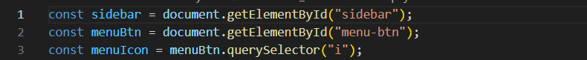
- Professional Coding Standards and Practices
This code demonstrates Professional Coding Standards and Practices because the CSS is organized and applies common styling rules in one place. The use of the universal selector (*) to define the margin, padding, box sizing, and font family establishes consistent formatting throughout the system and reduces the need to repeat the same styles for individual elements. This approach makes the code cleaner, more consistent, and easier to maintain. This code can be found in the file named dashboard_admin/style.css
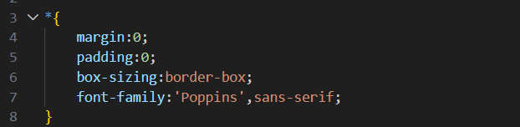
- 15 Principles of Quality Software
This code demonstrates the application of the SOLID Principles, particularly the Single Responsibility Principle (SRP), because different files are assigned to handle specific responsibilities. The HTML file is responsible for the structure and content of the page, the CSS file is responsible for the visual presentation, and the JavaScript file is responsible for interactive functions and user interactions. Separating these responsibilities makes the system easier to understand, maintain, and modify without unnecessarily affecting other parts of the system. This practice can be observed in dashboard_admin/index.html, dashboard_admin/style.css, and dashboard_admin/script.js.
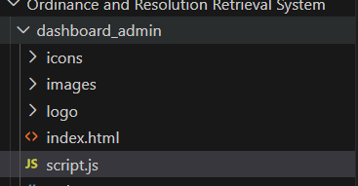
- 15 Principles of Quality Software
This code demonstrates Organizing a Package by Feature, Not Just by Layer because the system organizes related files according to their specific features or functions. The dashboard_admin folder contains the HTML, CSS, and JavaScript files needed for the administrator dashboard, while the log_in folder contains the files needed for the login feature. This organization keeps related components together, making the system easier to navigate, maintain, and modify. This practice can be observed in the dashboard_admin and log_in folders of the project.
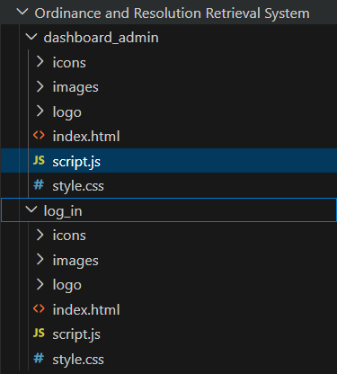
- Defensive Programming
This code demonstrates Defensive Programming because it checks whether the welcomeText element exists before attempting to modify its content. The if (welcomeText) condition prevents the program from trying to access or modify an element that may not be available, reducing the possibility of runtime errors. This makes the system more reliable and helps ensure that the program can handle unexpected situations safely. This code can be found in the file named dashboard_admin/script.js.
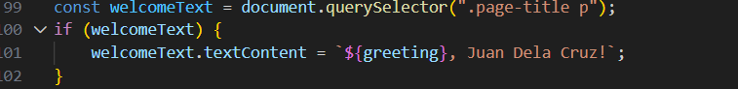
- Defensive Programming
This code demonstrates Defensive Programming because it checks whether the ripple element exists before attempting to remove it. The condition if (ripple) ensures that the program only performs the removal when the element is available, preventing potential errors that could occur when trying to access or remove a nonexistent element. This makes the system more reliable and helps the code handle unexpected situations safely. This code can be found in the file named dashboard_admin/script.js
